
Sri Lanka Institute of Information Technology

IE3142 : DevOps Security
Year 3, Semester 1- 2026

Name | IT Number
R.M.K.G.R.D.B Rajanayake | IT24102270
J. Shasmitha | IT24104218
G. F. Zikra | IT24104374
Weerasinghe S D | IT24103063

30.09.2026

Contents
1. Threat Modeling Methodology 1
2. System Scope 1
3. Assets 2
4. Trust Boundaries & Data Flow Diagram (DFD) 3
5. STRIDE Analysis 3
The table below summarises which STRIDE categories were found to apply within the scoped system, based on the architecture and data flows. 3
6. Detailed Threat Analysis 4
T3. Spoofing - Broken Authentication via Weak Password Reset 6
7. Threat Table Summary 9
8. Risk Matrix 10

1. Threat Modeling Methodology
Threat modeling is a structured approach to identify, analyze, prioritize, and mitigate potential security risks in the system architecture. For this assessment, we have used the STRIDE methodology. It evaluates threats across six distinct categories.
- S - Spoofing: Impersonating a user, system component, or process to gain unauthorized access.
- T - Tampering: Modifying data in transit or at rest to compromise system integrity or manipulate business logic.
- R - Repudiation: Performing actions without sufficient logging or audit trails, allowing an attacker to deny their actions.
- I - Information Disclosure: Exposing sensitive information to unauthorized users (e.g., IDOR, data leaks).
- D - Denial of Service (DoS): Exhausting resources or crashing services to make the application unavailable to legitimate users.
- E - Elevation of Privilege: Gaining higher access levels or administrative control from an unauthorized or low-privileged state.

2. System Scope
The application under assessment is a modern full-stack web application with the following architecture:
- Frontend: Angular Single Page Application (SPA) running in the user’s browser.
- Backend: Node.js server running Express.js to process REST API requests.
- Database: SQLite database managed via Sequelize ORM for persistent data storage.
- APIs: RESTful HTTP endpoints (/rest/..., /api/...) connecting the Angular frontend to the Express backend.
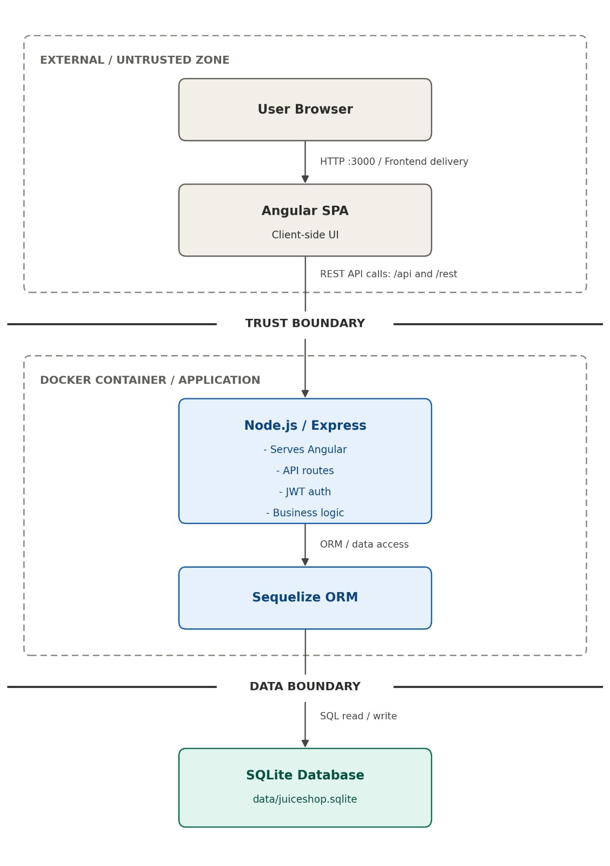
Figure 1: System Architecture

3. Assets
The high-value assets identified in this system include:
- Credentials & Authentication Data: Passwords, JWTs, session tokens, and security answers.
- User Personal Information: Email addresses, profile details, and user identifiers (UserId).
- Basket & Order Information: Order histories, item pricing, quantities, coupons, and active shopping cart states.
- Administrative Privileges: System administrative access, user management capabilities, and backend configuration rights.

4. Trust Boundaries & Data Flow Diagram (DFD)
Trust Boundaries
- Trust Boundary 1 (User / Internet Angular SPA): Untrusted user input enters the application via the browser interface.
- Trust Boundary 2 (Angular SPA Express REST APIs): Data crosses from the client browser into the backend server environment over HTTP/HTTPS.
- Trust Boundary 3 (Express Backend SQLite Database): Backend service queries and writes data to the persistent database.

5. STRIDE Analysis

The table below summarises which STRIDE categories were found to apply within the scoped system, based on the architecture and data flows.
Category | Applicable? | Notes
Spoofing | Yes | Weak identity verification in the password-reset flow (T2).
Tampering | Yes | Client-supplied basket/checkout values trusted by the server (T3).
Information Disclosure | Yes | Broken object-level authorisation on the basket endpoint (T1).
Elevation of Privilege | Yes | Client-controlled role field on registration (T4).

6. Detailed Threat Analysis
T1. Information Disclosure – IDOR on Basket Access
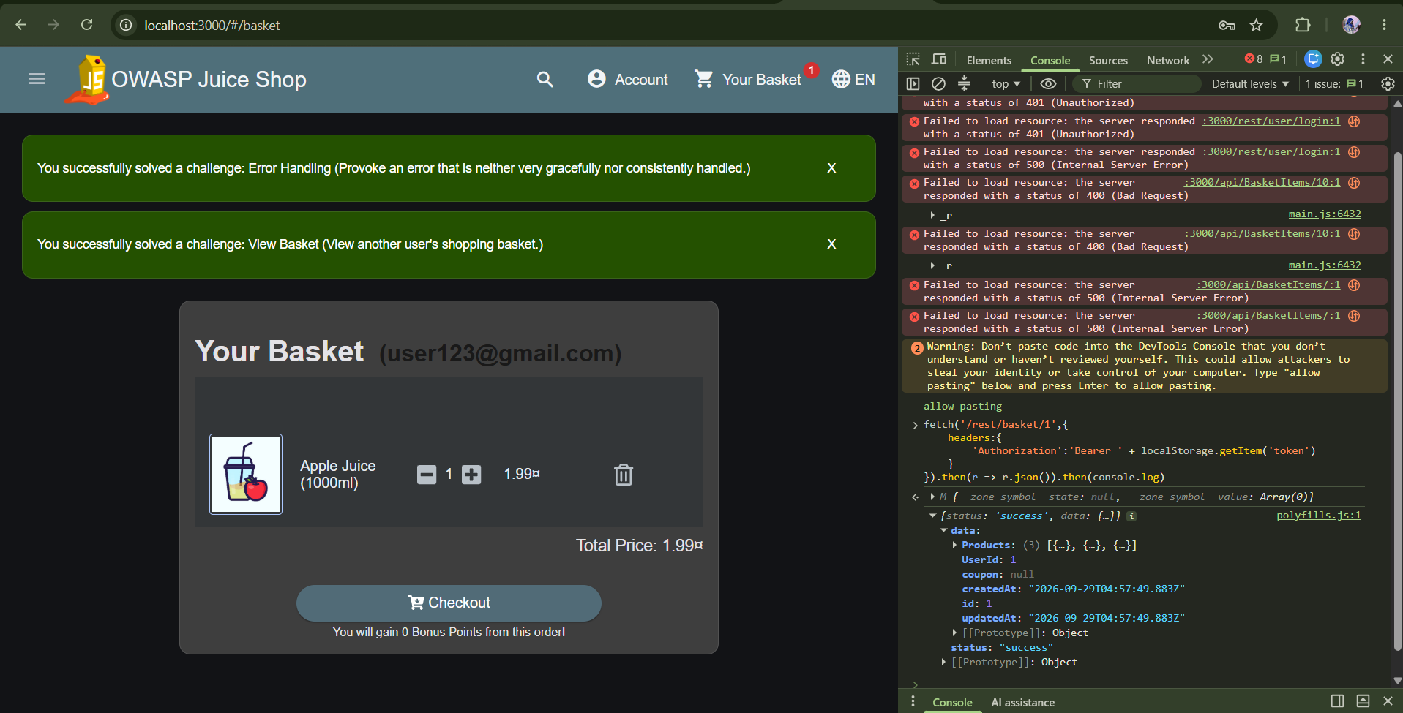

Component: Express backend - routes/basket.ts, retrieveBasket()
Attack scenario: An authenticated user changes the basket ID in the URL of a GET /rest/basket/:id request (e.g. from their own ID to /rest/basket/1) and receives another user's basket contents in the response, without any ownership check being performed.
Description:
The GET /rest/basket/:id endpoint accepts a basket ID directly from the URL and returns that basket's contents without verifying that the requesting user actually owns it. A logged-in user can substitute any basket ID (e.g. /rest/basket/1) and receive another user's basket data, including product contents.
Likelihood | Impact | Overall Risk
High (3/3) | Medium (2/3) | High
- Likelihood is rated High because the exploit requires no special tools or privileges, any authenticated user can trivially change a number in a URL or API request.
- Impact is rated Medium rather than High because the disclosed data (basket contents) does not include highly sensitive information like passwords or payment details, but it does violate user privacy and could expose purchasing behavior.
Control:
A server-side ownership check should be added in routes/basket.ts, inside the retrieveBasket() function, comparing the basket's UserId field against the authenticated user's ID (obtained via security.authenticatedUsers.from(req)) before returning any data. Requests failing this check should be rejected with a 403 Forbidden response.

T2. Spoofing - Authentication Bypass via SQL Injection
Component: Express backend - authentication route handling POST /rest/user/login (login query logic against the Users table)
Attack scenario: An attacker submits a specially crafted string, such as ' OR 1=1--, in the email field of the login form instead of a real email address, along with any arbitrary value in the password field. Because the backend builds its SQL query by directly concatenating this input into the query string rather than treating it as data, the injected OR 1=1 condition makes the WHERE clause match the first row in the Users table regardless of the actual credentials supplied. The application then authenticates the attacker as that user, typically the first-created account, which is often the administrator, without ever validating a real password.
Description:
The login endpoint constructs a database query using user-supplied email/password input. If input is not properly parameterised, an attacker can inject SQL syntax (e.g. ' OR 1=1--) into the email field to bypass authentication entirely and log in as another user, including an administrator, without knowing their password.
Likelihood | Impact | Overall Risk
Medium (2/3) | High (3/3) | High
- Likelihood is rated Medium because it requires the attacker to know the login form is vulnerable and craft the correct injection payload, which is more effort than the basket IDOR
- Impact is rated High because a successful bypass grants full account takeover, potentially including admin access, compromising confidentiality and integrity across the whole application
Control:
The login query logic (in the authentication route handling POST /rest/user/login) must use parameterised queries via Sequelize's safe query builder methods rather than concatenating raw SQL strings, ensuring user input is always treated as data, never executable query syntax.

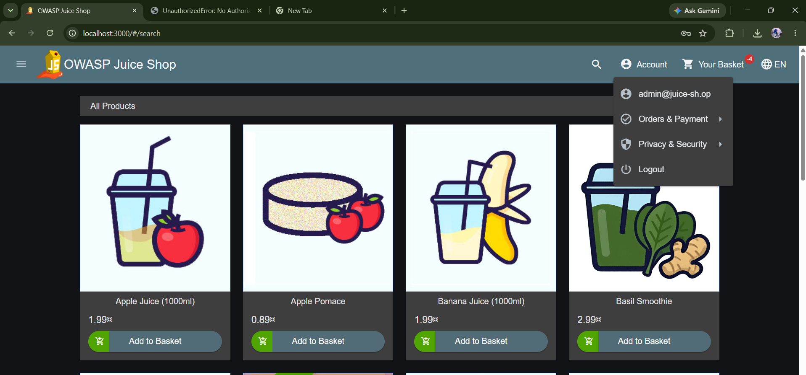

T3. Spoofing - Broken Authentication via Weak Password Reset
Component: Express backend - routes/resetPassword.ts, routes/securityQuestion.ts, server.ts (rate limiter)
Attack scenario: An attacker looks up a target account's security question via the unauthenticated /rest/user/security-question endpoint, researches or guesses the answer (for account jim@juice-sh.op, the question references a well-known pop-culture fact), and submits it to /rest/user/reset-password to set a new password. Because the endpoint's rate limiter keys on the client-controlled X-Forwarded-For header rather than the real IP, an attacker can send unlimited guesses by spoofing a different header value on every request, turning a single lucky guess into an unlimited, automatable brute-force attack.
Description: The 'Forgot Password' flow authorises a password reset using only a static security question as proof of identity, with no meaningful protection against automated guessing. The question for at least one account references publicly documented trivia, making the answer researchable rather than secret. This was compounded by a rate-limiter bypass: server.ts configures the reset-password endpoint's rate limiter with a keyGenerator that trusts the client-supplied X-Forwarded-For header, which can be freely spoofed to make every request appear to come from a different client.
Likelihood | Impact | Overall Risk
High (3/3) | High (3/3) | High

- Likelihood is rated High because the security question is researchable and the rate limiter offers no real protection once the header-spoofing issue is known, making this exploitable by a scripted attacker with no special access or privileges.
- Impact is rated High because a successful attack grants full account takeover without ever knowing the original password, and the rate-limiter bypass means the attack scales to any account, not just one with an easily guessed question.
Control: Remove the client-controlled keyGenerator from the rate limiter configuration in server.ts and disable trust proxy, allowing express-rate-limit to fall back to its safe default of keying on the real, resolved client IP address. This was implemented, re-tested against the same 150-request bypass script (100 requests succeeded and 50 were correctly blocked with 429 Too Many Requests, matching the intended limit), and confirmed with a before/after Semgrep scan.
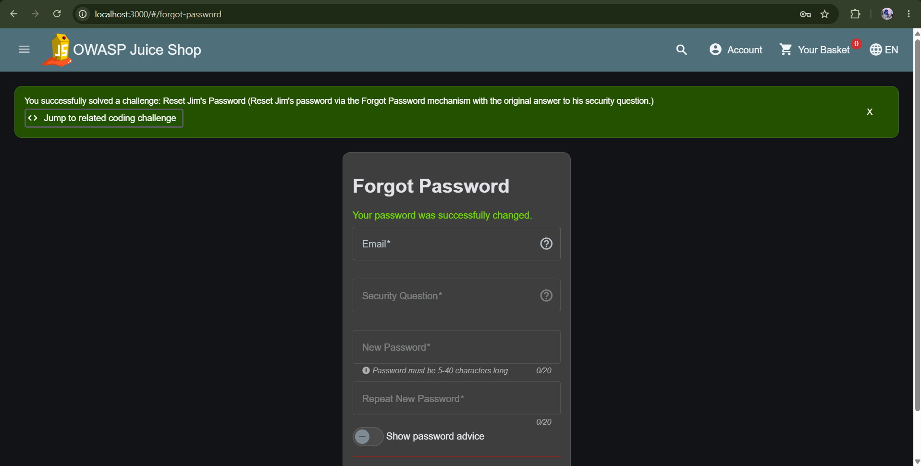
T4. Tampering - Client-Trusted Data in Basket/Checkout Requests
Component: Express backend - checkout/order route handlers
Attack scenario: A user intercepts the REST API request sent when adding an item to their basket or proceeding to checkout, using browser developer tools, and edits the price or quantity field in the request body before it reaches the server
Description:
Requests to add or modify basket items are sent from the Angular SPA to the Express backend as REST API calls. If the server trusts client-supplied values (such as price or quantity) without recalculating them from the database, an attacker can intercept and modify the request (e.g. via browser dev tools) to alter the checkout price or manipulate quantities before the order is processed.

Likelihood | Impact | Overall Risk
Medium (2/3) | High (3/3) | High
- Likelihood is rated Medium intercepting and editing requests requires basic familiarity with browser developer tools, which is more accessible than crafting SQL payloads but still requires deliberate action, not something a casual user stumbles into.
- Impact is rated High because it directly affects business logic and financial integrity: an attacker could purchase products at manipulated prices, causing direct financial loss.
Control:
All price and cost calculations must be performed server-side in the checkout/order logic, recalculating totals directly from the product data in the database via Sequelize, rather than trusting any price or discount fields sent from the client.
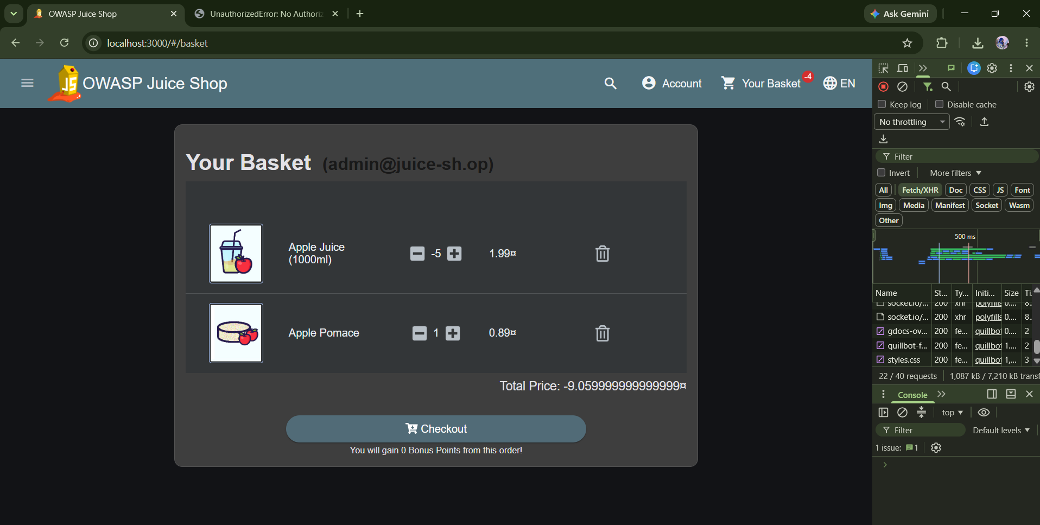

T5. Elevation of privilege
Component: Express backend - user registration route handler
Attack scenario: An attacker calls the registration API directly (bypassing the UI, which does not expose a role field) and includes "role": "admin" in the request body when creating a new account.
Description:
The user registration endpoint may accept a role field as part of the request body. If the server does not strip or override client-supplied role values, an attacker can include "role": "admin" in their registration request and be granted administrative privileges immediately upon account creation, without any legitimate authorisation process.

Likelihood | Impact | Overall Risk
Low (1/3) | High (3/3) | Medium

- Likelihood is rated Low because this requires the attacker to know or guess that the registration endpoint accepts an unexpected role field, which is not visible in the normal UI and requires direct API manipulation.
- Impact is rated High because a successful exploit grants full administrative access to the application from a brand-new, unvetted account, undermining the entire access control model.
Control:
The user registration handler must explicitly ignore or strip any role field present in the incoming request body, assigning the default customer role server-side regardless of what the client submits. Role elevation should only ever be possible through a separate, properly authorised administrative process.
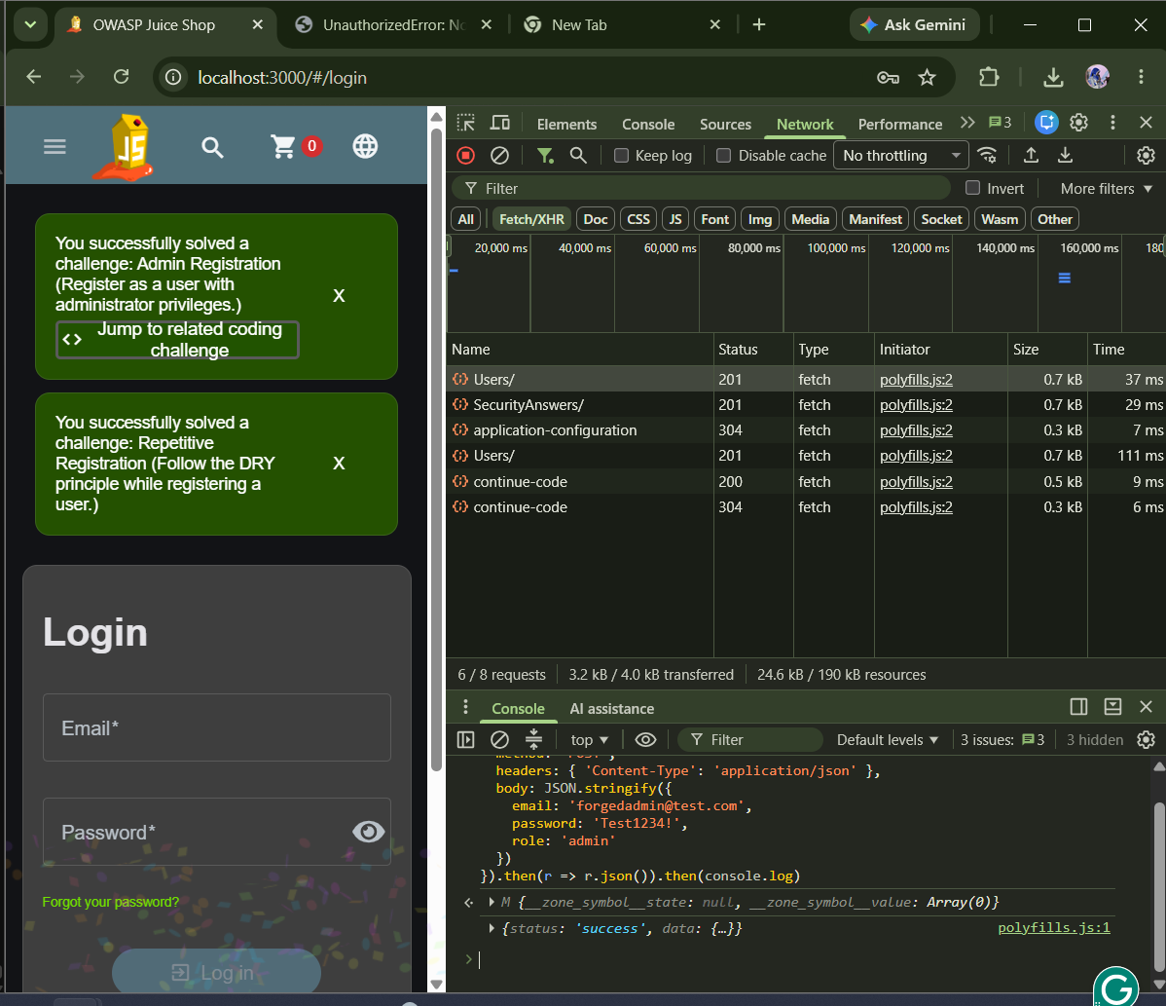

7. Threat Table Summary

Threat | STRIDE Category | Likelihood | Impact | Overall Risk
IDOR on Basket Access | Information Disclosure | High | Medium | High
Broken Authentication via Weak Password Reset | Spoofing | High (3/3) | High (3/3) | High
SQL Injection Login Bypass | Spoofing | Medium | High | High
Basket/Price Tampering | Tampering | Medium | High | High
Forged Role Registration | Elevation of Privilege | Low | High | Medium

8. Risk Matrix
Impact ↓ / Likelihood → | Low | Medium | High
High | T5 Forged Role Registration (Medium risk) | T2 SQL Injection Login Bypass (High risk)  T4 Basket/Price Tampering (High risk) | T3 Broken Authentication via Weak Password Reset (High risk)
Medium |  |  | T1 IDOR on Basket Access (High risk)
Low

